Lexical Analyzer

Create a Scanner of the C-Minus Compiler

**Prepared By**

Student Name Student ID

**Karim Wael Nabil**

**200010888**

**Under Supervision**

Dr./ Nehal A. Mohamed

T.A/ Fares

**Abstract**

**Code**

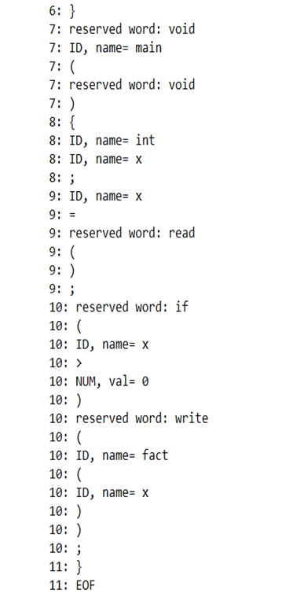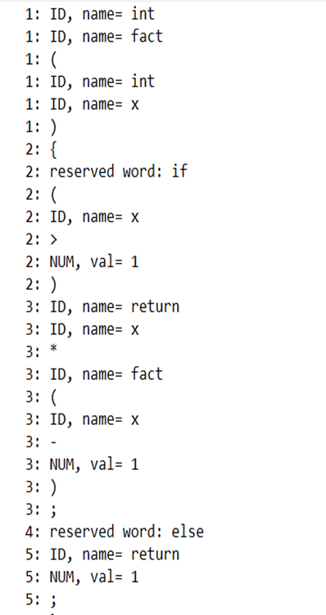**Code**

##### ***Table of Contents***

|  |  |
| --- | --- |
| **Content** | **Page** |
| **Table of Contents ………………………………………………………………….** |  |
| **List of Tables ………………………………………………………………………** |  |
| **List of Figures ……………………………………………………………………..** |  |
| * 1. **Introduction ……………………………………………………………………** |  |
| * 1. **Description of Frontend of the Compiler …………………………………….** |  |
| * + 1. **Lexical Analyzer …………………………………………………………** |  |
| * + 1. **Syntax Analyzer ………………………………………………………….** |  |
| * + 1. **Semantic Analyzer ……………………………………………………….** |  |
| * 1. **Programming Language ……………………………………………….……...** |  |
| * + 1. **List of Reserved Words ………………………………………………….** |  |
| * + 1. **List of Keywords …………………………………………………………** |  |
| * + 1. **Basic Grammar Rules …………………………………………………...** |  |
| * 1. **Software Tool(s) ………….………….………….………….………….………** |  |
| * 1. **Discussion ………………………………………….…………………………...** |  |
| * + 1. **Input of Lexical Analyzer ……………………………………………….** |  |
| * + 1. **Output of Lexical Analyzer ……………………………………………..** |  |

##### ***List of Tables***

|  |  |  |
| --- | --- | --- |
| **Table No.** | **Title** | **Page** |
|  |  |  |
|  |  |  |
|  |  |  |

##### ***List of Figures***

|  |  |  |
| --- | --- | --- |
| **Figure No.** | **Caption** | **Page** |
|  |  |  |
|  |  |  |
|  |  |  |
|  |  |  |
|  |  |  |
|  |  |  |
|  |  |  |
|  |  |  |
|  |  |  |
|  |  |  |
|  |  |  |
|  |  |  |
|  |  |  |
|  |  |  |
|  |  |  |
|  |  |  |
|  |  |  |

1. **Introduction**
   1. **Phases of Compiler**
2. **Description of Frontend of the Lexical Analyzer**
   1. **Lexical Analyzer**
   2. **Syntax Analyzer**
   3. **Semantic Analyzer**
3. **Programming Language**
   1. **List of Reserved Words**
   2. **List of Keywords**
   3. **Basic Grammar Rules**
4. **Software Tool(s)**
5. **Discussion**
   1. **Input of Lexical Analyzer**
   2. **Output of Lexical Analyzer**
6. **Conclusion**
7. **References**
8. **Appendices**

**Important Note: -**

Technical reports include a mixture of text, tables, and figures. Consider how you can present the information best for your reader. Would a table or figure help to convey your ideas more effectively than a paragraph describing the same data?

Figures and tables should: -

* Be numbered
* Be referred to in-text, e.g. *In Table 1*…, and
* Include a simple descriptive label - above a table and below a figure.